
SWISS-DESIGNED ART YARN LANARTUS from Angel Yarns

AMALFI

TOP

Simple stocking stitch
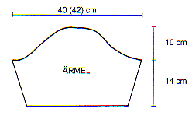
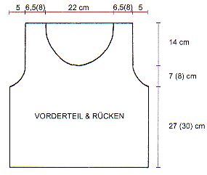
Size + material:
Size: 36- 38 + (40-42)
Material:
7 (8) balls AMALFI
7 mm needle
6 mm crochet hook
Tension:
12 sts + 18 row = 10 cm
Back:
Cast on 54 (58) sts.
K in stst 27 (30) cm.
Shaping armholes:
Dec on both sides in each 2nd row, 1 time 2sts and 4 times 1sts.
Cast off if your work measures 48 (52) cm..
Front:
K the same as for back part.
If your work measures 34 (38) cm , divide the middle and cast off 8 sts.
K both sides separately.
Shaping neckline:
Dec in every 2nd row, 2 times 2 sts and 5 times 1 sts. Finally cast off if your work measures 45 (52) cm.
Sleeves:
Cast on 38 (40) sts.
Inc in every 4th row on both sides 5 times 1 sts.
If your work measures 14cm - shape armpits: Dec in every 2nd row 1 times 2 sts, 4 times 2 sts and 4 times 2 sts.
Cast off rem 20 (22) sts.
Making up:
Sew together all parts and crochet all edge with double crochet.
Back + front
sleeves

ABBREVATIONS

K = knit

sts = stitch

inc = increasing

dec = decreasing
stst = stocking stitch
folls = following
rem = remaining
rev = reversing
altz = alternate
cont = continue
cm = centimetre
mm = millimetre

