Angel Yarns
SWISS-DESIGNED LANARTUS

AMALFI

Long-sleeved Jumper

Simple stocking stitch
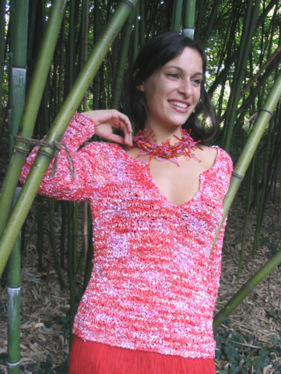

SIZE + MATERIAL
36-38 and (40-42)
9 (10) ball AMALFI
7mm needles.
6 mm crochet hook

Back:
Cast on 56 (60)
K 36 (39) cm

To shape armholes
Cast off 2 stitches then every 2nd row, cast off 1 stitch, four times.
Next, cont straight until work measures 57 (61) cm. Cast it all off.

Front: Repeat as for back.

For the slit
3 cm before you start for the armholes, divide the knitting in the middle and knit each side separately.
K 12 (13 cm) and start
dec for the neckline.
Every 2nd row on the side of the neckline, dec 1 times 4 (5)sts and 4 times 1 sts.
Cont working until work measures 57 (61) cm.

Cast off rem stitches.

Sleeves
Cast on 29 (31) stitches.
Inc by 1 stitch on every 9th needle (and for size 40-42 every 10th needle.) for six times.
K 36 (38) cm

To shape armholes
On every 2nd row, cast off as follows:
2 times 2 sts then 3 times 1 sts.
Now on each 4th row:
3 times 1 sts
On each second row:
3 times 1, 2 times 2 stitches. Finally cast off the rem knitting.

Making up:
Sew the parts together. Finish off all edges and neckline with one line of crochet.

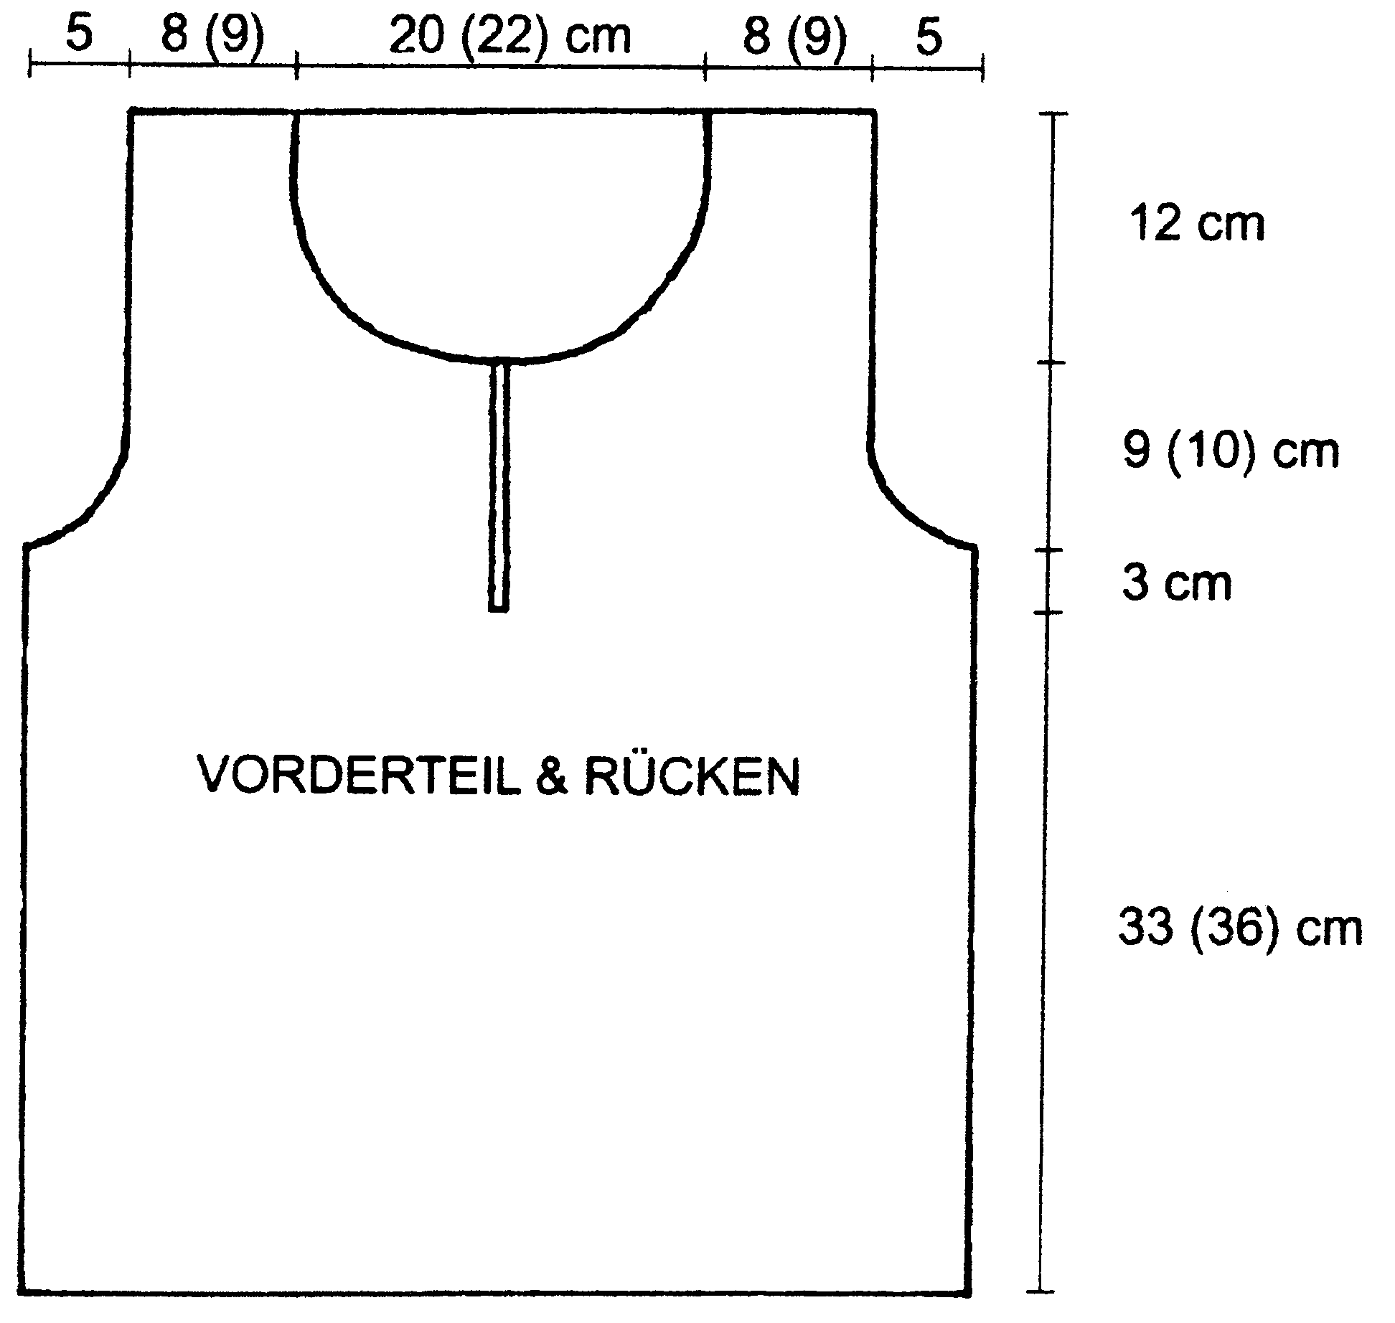

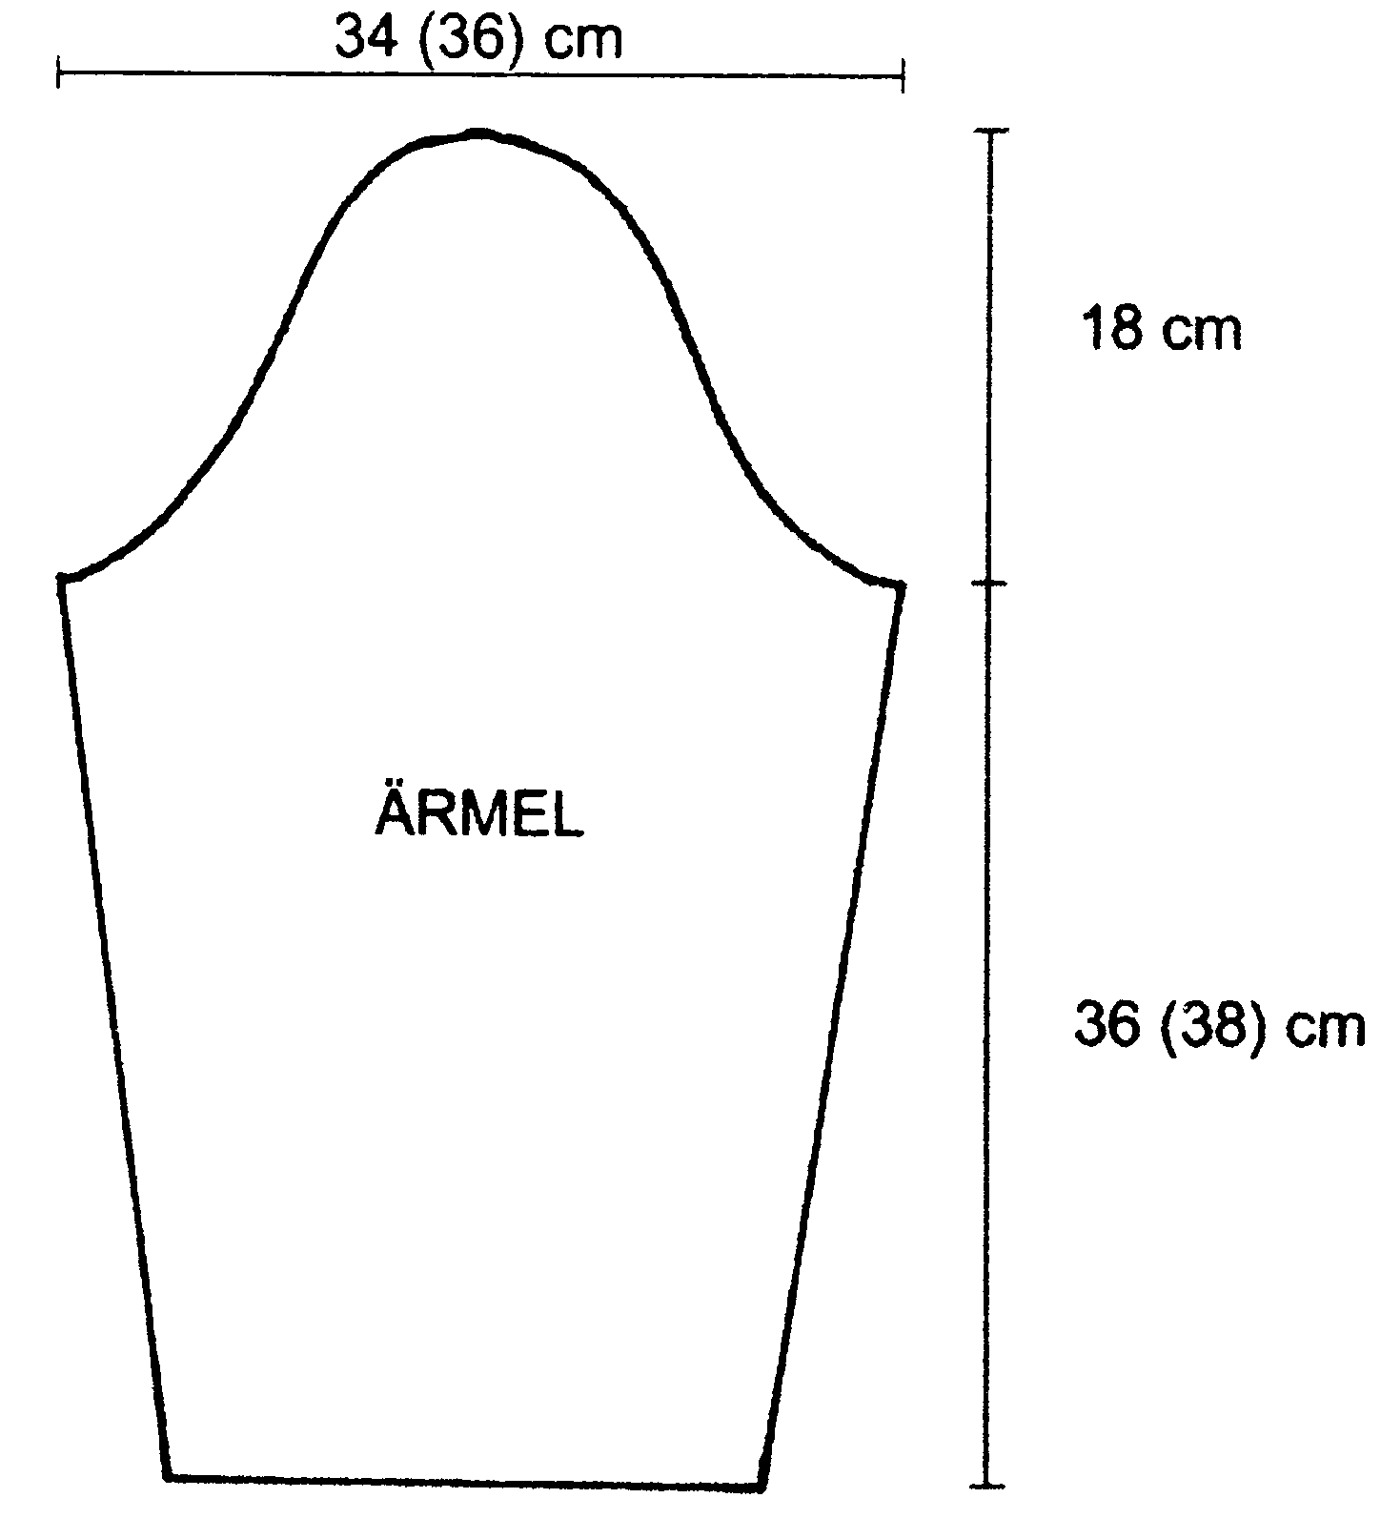

Front + back
sleev

